Moving Man PHET Simulation Name ___________________________________ Date _______
Part 1: Position and Velocity
Introduction Tab
- Using the blue “Position” slider, answer the following:
  - If the position is positive, is the moving man to the right or left of the center? _________________
  - If the position is negative, is the moving man to the right or left of the center? ________________

- Using the red “Velocity” slider, type the following numbers into the box and fill in the table with the correct information.
Velocity | Speed (fast or slow) | Direction (left or right)
+5
+0.5
-5
-0.5
Charts Tab
- Click on the “Charts” tab at the top left.
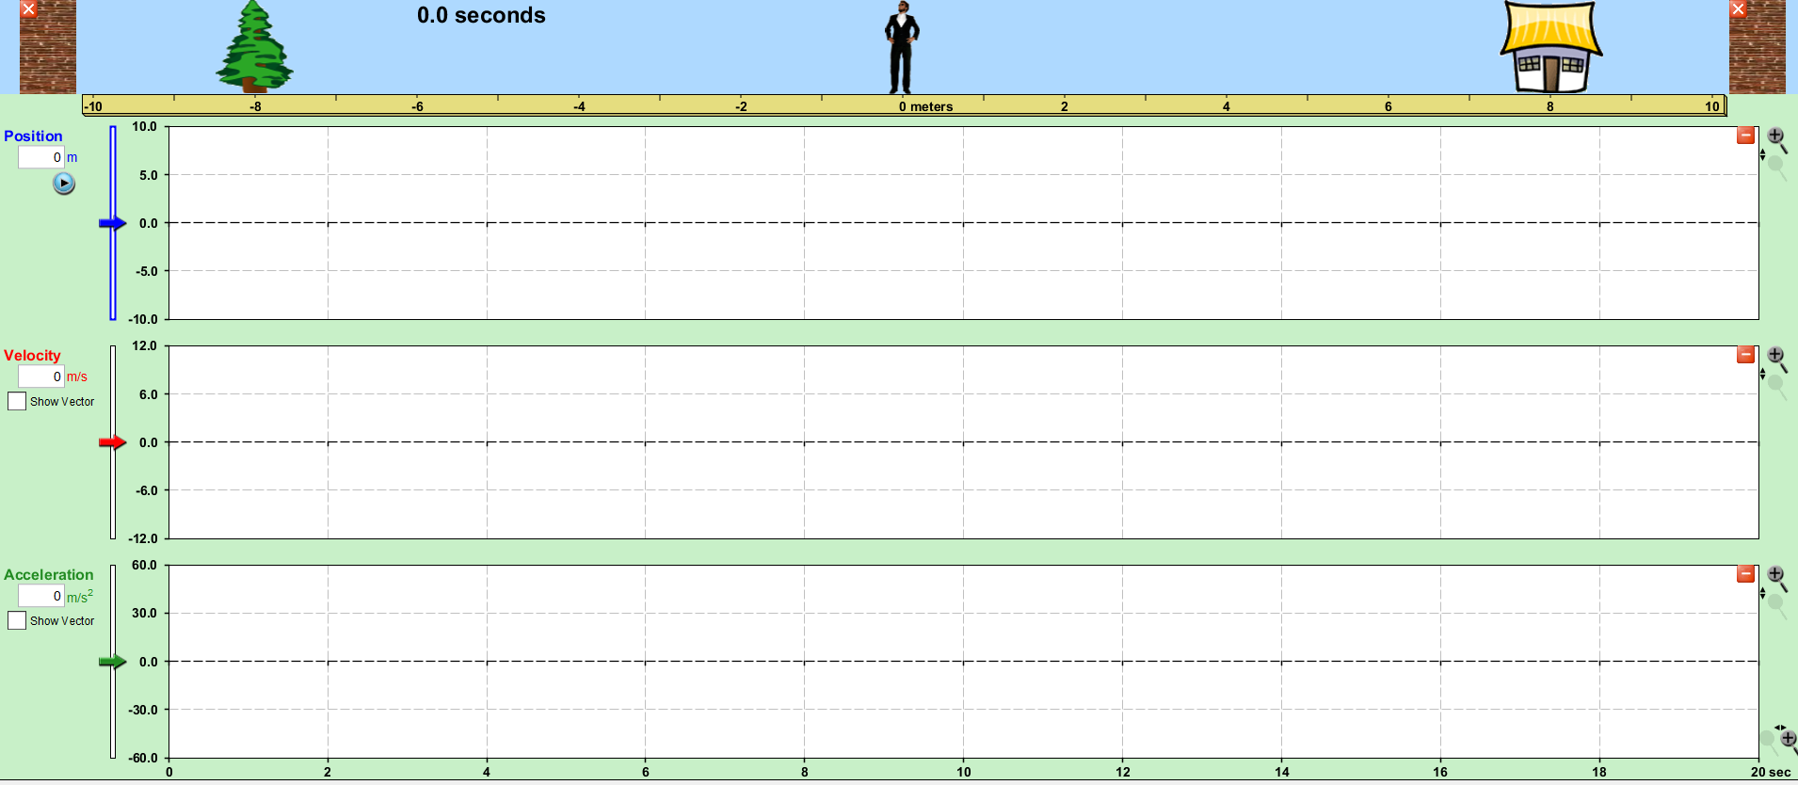
- Remove the “Acceleration” graph by clicking the red box on the top right of the “Acceleration” graph.

- Click on the “Show Vector” box under the red “Velocity” heading.

For the following parts, enter the specifications into the simulation and then graph on the corresponding graph. You will have more than one line on each graph so you may want to us a different color for each graph. Answer the questions after each graph.
- High vs Low Positive Velocity

  - Graph 1
position: 0 m
velocity: +2 m/s
time: 4 sec
  - Graph 2
position: 0 m
velocity: +0.5 m/s
time: 4 sec

  - How does the position graph for the 2 m/s (high, positive velocity) differ from the 0.5 m/s (low, positive velocity)?

  - How does the velocity graph for the 2 m/s (high, positive velocity) differ from the 0.5 m/s (low, positive velocity)?

- High vs Low Negative Velocity

  - Graph 1
position: 0 m
velocity: -2 m/s
time: 4 sec

  - Graph 2
position: 0 m
velocity: -0.5 m/s
time: 4 sec

  - How does the position graph for the -2 m/s (high, negative velocity) differ from the -0.5 m/s (low, negative velocity)?

  - How does the velocity graph for the -2 m/s (high, negative velocity) differ from the -0.5 m/s (low, negative velocity)?

- Positive vs Negative Velocity

  - Graph 1
position = 0 m
velocity = -2 m/s
time = 4 sec

  - Graph 2
position = 0 m
velocity = +2 m/s
time = 4 sec

  - How does the position graph for a negative velocity differ from positive velocity?

  - How does the velocity graph for a negative velocity differ from positive velocity?

- Zero Velocity

  - Graph 1
position = 2 m
velocity = 0 m/s
time = 4 sec

  - Graph 2
position = -8 m
velocity = 0 m/s
time = 4 sec

  - Graph 3
position = 0 m
velocity = 0 m/s
time = 4 sec

  - How does the position graph differ when the position is changed and velocity is 0 m/s?

  - How does the velocity graph differ when the position is changed and velocity is 0 m/s?

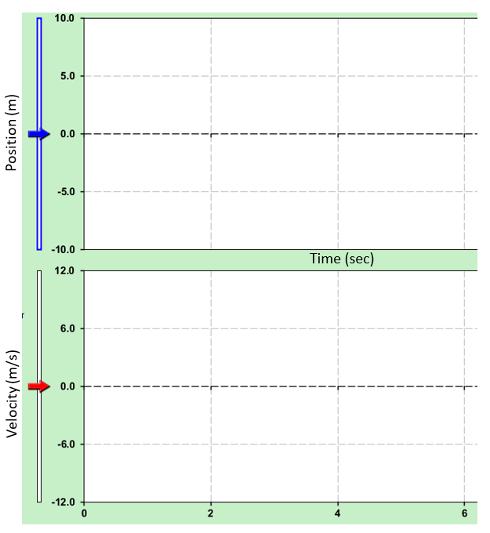
- On the graph to the right, draw what you think both the graphs would look like if the Moving Man started at -10 m and had a velocity of +4 m/s for 4 seconds.

Now, enter -10 m for position and +4 m/s for velocity and let it run for 4 seconds. Was your predicted graph correct?

- On the graph to the right, draw what you think both the graphs would look like if the Moving Man started at +8 m and had a velocity of -2 m/s for 4 seconds.

Now, enter +8 m for position and -2 m/s for velocity and let it run for 4 seconds. Was your predicted graph correct?

Using information from the simulation, complete each of the following rules:
- The position graph line is on the positive side when ___________________________________________________.
- The position graph line is on the negative side when ___________________________________________________.
- The position graph line has a positive slope when _____________________________________________________.
- The position graph line has a negative slope when _____________________________________________________.
- The position graph line has zero slope when __________________________________________________________.
- The velocity graph line is on the positive side when ___________________________________________________.
- The velocity graph line is on the negative side when ___________________________________________________.
- The velocity graph line is on zero when ______________________________________________________________.
- The slope of the line on the position graph is steep when ________________________________________________.
- The line on the velocity graph is closer to zero when ___________________________________________________.
- The line on the velocity graph is far from zero when ___________________________________________________.

