Angry Birds Assignment
Using the Angry Birds and Angry Birds Seasons applications (the free versions work fine), you are going to explore the physics of eliminating green pigs. Using the following birds, you are going to figure out how to win the game:
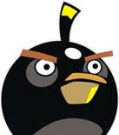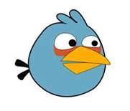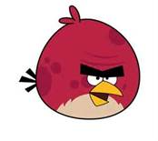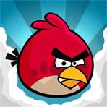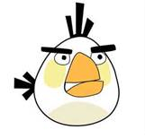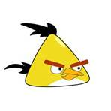

The grade will be based on the following requirements:
- Using specific examples, describe how the following terms apply to the game:
  - Velocity
  - Acceleration
  - Force
  - Gravity
  - Mass
  - Projectile motion
  - Newton’s 1st law
  - Newton’s 2nd law
  - Newton’s 3rd law
- What each bird does when you tap on the screen (if it does anything) and what it does well.
- Which bird(s) is best for each type of material listed here:
  - Wood
  - Concrete
  - Ice
  - Snow/clouds (they kinda look the same)
- State what strategies you use to beat the game (aim for, shoot high, tap the screen after…).
This game is ideal for the study of physics, because so many things apply to what we study in class. Good luck and enjoy. The paper is due on Wednesday, 12/19/12.

